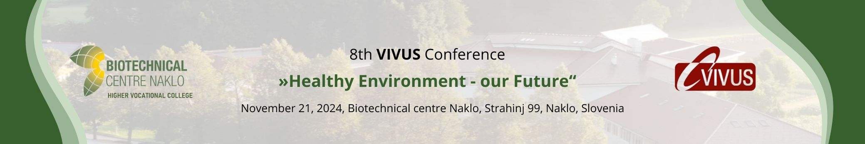

8th Conference VIVUS
on Agriculture, Forestry, Environmentalism, Environment protection, Horticulture, Food Technology and Nutrition and Countryside

»Healthy environment – our future«

Declaration of Authorship 2024

DECLARATION OF AUTHORSHIP FOR PAPER
FOR THE VIVUS CONFERENCE 2024

AUTHOR'S DATA

Name and surname: ____________________________________________________________________________
Paper's title: _____________________________________________________________________________
___________________________________________________________________________________________________
The conference session: _______________________________________________________________________

DECLARATION

I hereby certify that:

- the submitted manuscript is an exclusive result of my work;

- all works and opinions of other authors reffered to in the submitted manuscripts have been accordingly cited;

- all works of other authors reffered to have been collected in a list of bibliographic references included in my manuscript;

- I have acquired all permissions for usage of authorial works that have been fully transmitted into the submitted manuscript, which has been clearly described in the submitted manuscript;

- I am aware that plagiarism – as presenting of other works in forms of citation or nearly literal paraphrasing or graphical forms, with clear intention to present other thougths and ideas as my own – is a criminal act in violation of law (Law on authorship and Related Rights, Official Gazette of RS, no. 21/95, 68/2008);

- the manuscript has been reviewed and corrected and the components of the paper organized in accordance with the instructions for the shaping of abstracts and papers, published on the VIVUS conference website.

Date: Author's signature
________________________ _______________________________

Biotechnical Centre Naklo, Strahinj 99, 4202 Naklo, Slovenia

