The Structure of the Education System in Slovenia

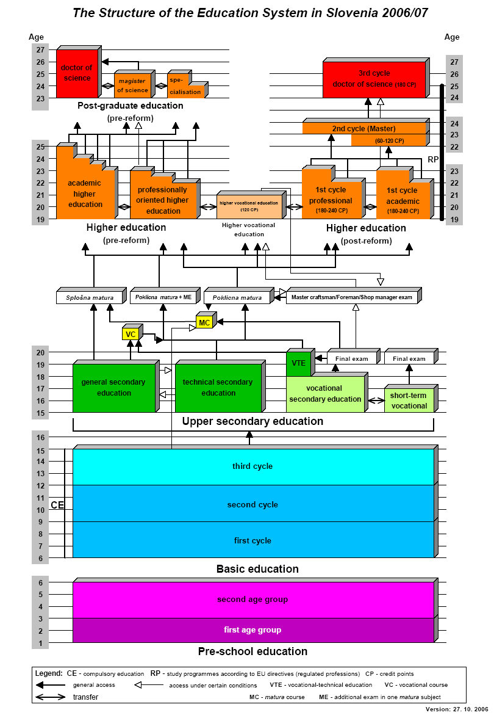

Information about the educational system in the Republic of Slovenia
Tertiary education in the Republic of Slovenia is settled by the Legislation of the higher vocational education and the Legislation of the higher education. The Legislation of the higher vocational education has been effective as from 6th August 2004, the Legislation of the higher education has been effective as from 1st January 1994, its amendments were adopted on 24th December 1999. There is the undergraduate and post-graduate study programme. There are higher vocational, higher professional and university undergraduate study programmes. Faculties and academies can carry out university and higher education professional programmes, higher professional schools can carry out higher education professional programmes, higher vocational schools can carry out higher vocational educational programmes. Post-graduate study programmes are: programmes for acquiring specialisation, programmes for acquiring the master-of-science degree and programmes for acquiring the doctor-of-science degree. After undergraduate programmes you obtain a graduation certificate and a so-called first professional title; after post-graduate programmes it is possible to obtain second graduation certificate and second professional title specialist or academic titles master of science or art and doctor of science. Names of professional education, professional and scientific titles are defined according to the Legislation of professional and scientific titles (Official Gazette of RS, no. 61/2006). A professional and scientific title acquired abroad is acknowledged in Slovenia if a graduation certificate issued abroad is also acknowledged in Slovenia.

An individual can apply for a higher vocational study programme if he/ she passed the matura or the vocational matura final exam or a final exam after a four-year secondary school or any other equivalent educational programme, or if he/ she has passed a Master craftsman/ Foreman/ Shop manager exam, has three-year working experiences and has passed a test from the following subjects: Slovene language and literature and mathematics or a foreign language in the extent determined for a vocational matura exam in the secondary school education. The programmes last for two years. They are completed with a public presentation of the diploma thesis. A professional title a student acquires after successfully completing the study is written in a graduation certificate. After a completed professional study the graduation certificate enables a student to find a suitable job or to continue his/ her studies on specialising or higher professional study programmes. A transition from a higher vocational to a higher educational professional study is under certain conditions possible in both directions.

An individual can apply for a programme of specialisation if he/ she has a graduation certificate from a higher vocational study. The programmes last up to one year and are evaluated for 10 to 35 CP. The study programmes of specialisation are meant to specialise, complement, modernise and deepen your knowledge and skills on the same level of difficulty, but they enable a person to acquire a new professional education title.

